Texas Department of Public Safety

IT

CJIS NICS User Guide

Version 3.1.2
July 17, 2012

Authored by: Charles Golson
Edited by: Ursula Cook

Table of Contents
If you are viewing this document on-line, CTRL+click the target page number in the Table of Contents. Then to return to the Table of Contents, click the left arrow icon on Word's Web toolbar. Alternately, CTRL+HOME takes you to the top of the document.
Introduction 3
Contacts 3
Login to CJIS 4
Enter USER ID 4
Enter Password 5
Inbox 6
Federal Firearm Reporting 7
Online Entry of NICS Transactions 7
Online Entry of NICS Zero Activity Reports 10
Online Search and Cancel of NICS Transactions 12
File Upload 15
Reports 17
Report Example – NICS Transaction Report 18
Report History 21
Transaction Formats 22
TRANSACTION HEADER 22
NICS ENTRY SEGMENT (MKE = ‘EDP’) 23
NICS CANCEL SEGMENT (MKE = ‘XDP’) 24
ADMIN 25
Security profile 25
Security Image and Site Phrase 26
Security Questions 27
Passwords 28
Authentication Code 30
Authorized User Acknowledgement 32
Document Revision History 34

Introduction

The Criminal Justice Information System (CJIS) site is provided by the Texas Department of Public Safety to assist counties in managing their Computerized Criminal History (CCH) information and their Federal Firearms Reporting transactions.

The major areas of the site are:

The Inbox section lists all previously requested reports and any automatically generated reports and notices from TxDPS.

The Reports section allows authorized users to request reports for their county. Most reports are available in HTML, PDF, and CSV formats and can be downloaded if desired.

The NICS section allows submission of individual Federal Firearm reporting transactions to TxDPS, who forwards them to the National Instant Criminal History Background Check system (NICS).

The Admin section allows users to manage their security profiles. Users can change their password, update their security questions and responses, select a security photo and corresponding phrase.

Contacts

HQ DPS | CHRIP Manager | Ursula Cook | (512) 424-2407
HQ DPS | EDR Coordinator

Login to CJIS

Connect to the Internet and CCH/CJIS (CJIS) by typing the following URL:
https://cch.txdps.state.tx.us

Enter USER ID

Login by typing your work e-mail and click Login.

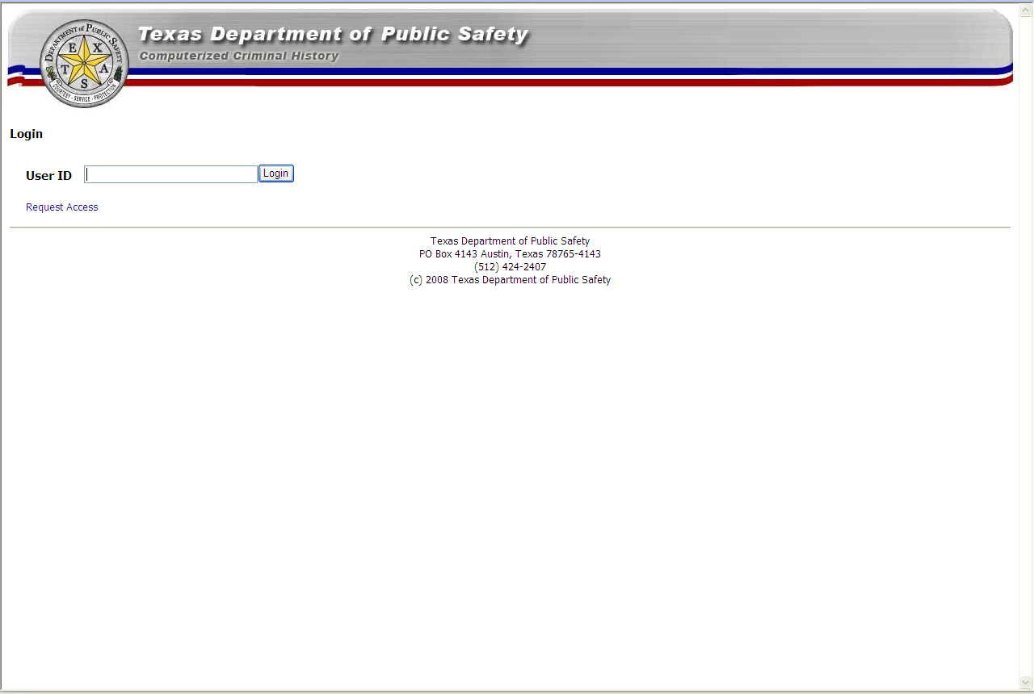

Note: You must be registered as a CJIS user to logon. If you are not currently an authorized user, you may click Request Access and complete the application form which will be sent to TxDPS for consideration. A confirmation of your request and instructions will be emailed to you.

Enter Password

Verify that your security image and phrase are accurate.
Enter your password and click Sign On.

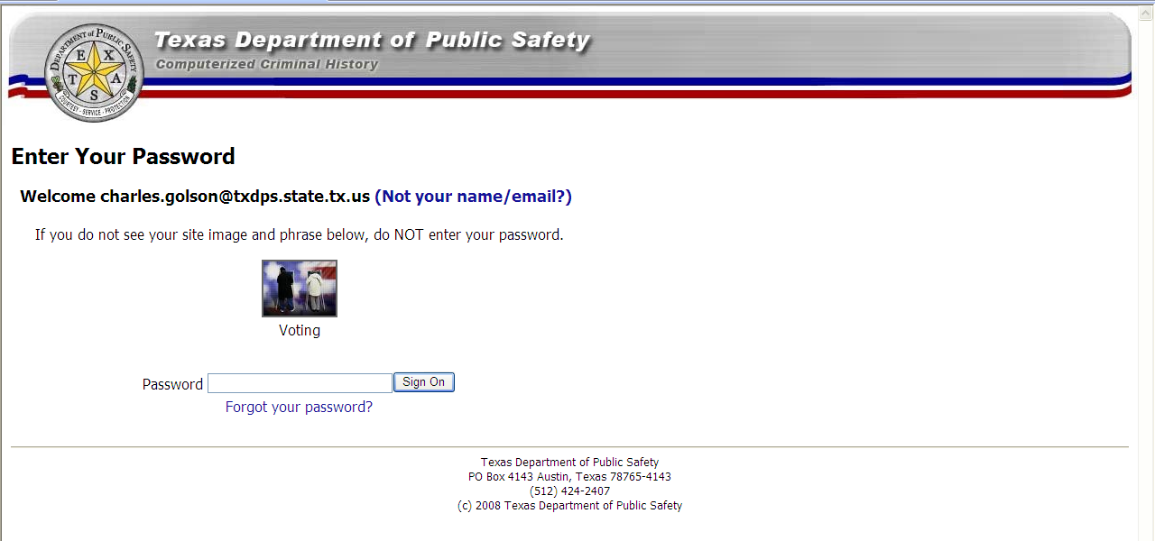

Inbox

The CJIS home page defaults to your Inbox page.

The information displayed in your Inbox lists your most recently delivered reports or notifications. Click the desired Report or Notification to view the report.
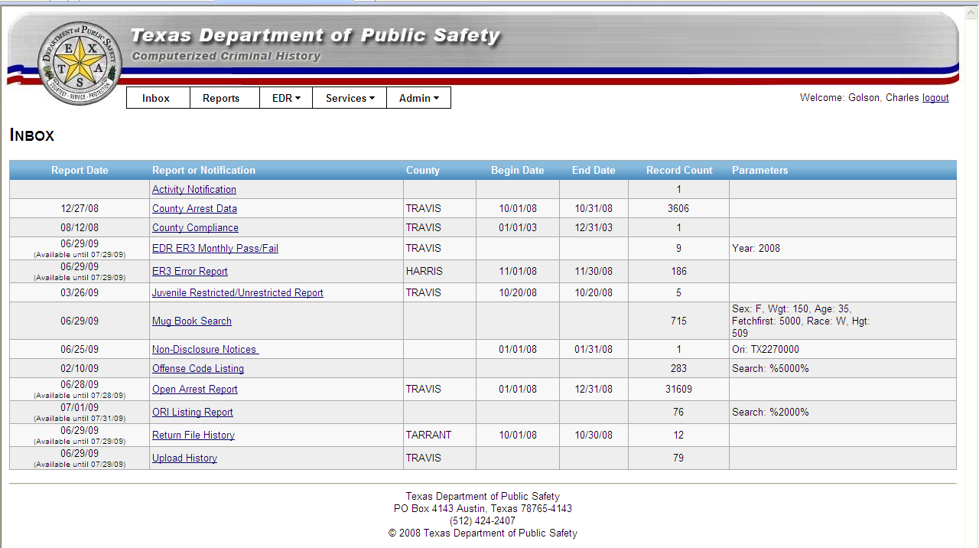

Reports and notifications remain in your Inbox until the “Available until” date. The default retention period is 30 days. An example ORI Listing Report:

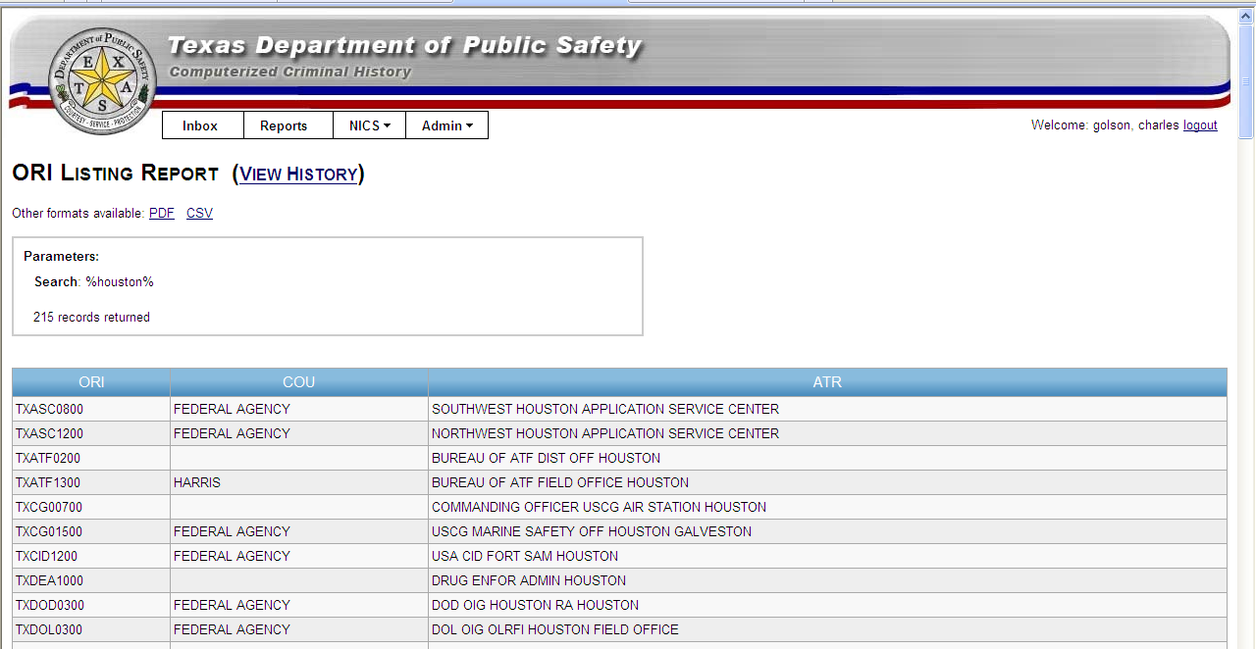

Federal Firearm Reporting

Counties are required to report federal prohibited person information to the Department under 411.052 of the Government Code. If there are no court determinations for a month, then counties must enter a zero activity report for that month to be considered in reporting compliance.

Online Entry of NICS Transactions

Individual NICS transactions may be entered via the CJIS site by selecting NICS > Online Entry > Individual Record.

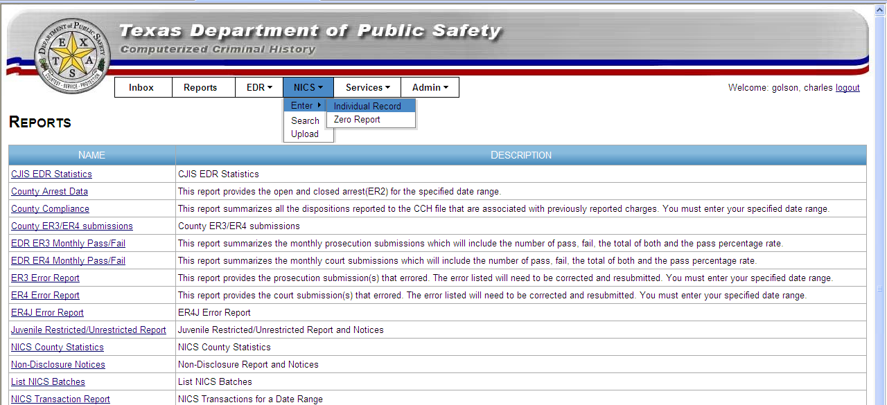

A blank entry form will be displayed.

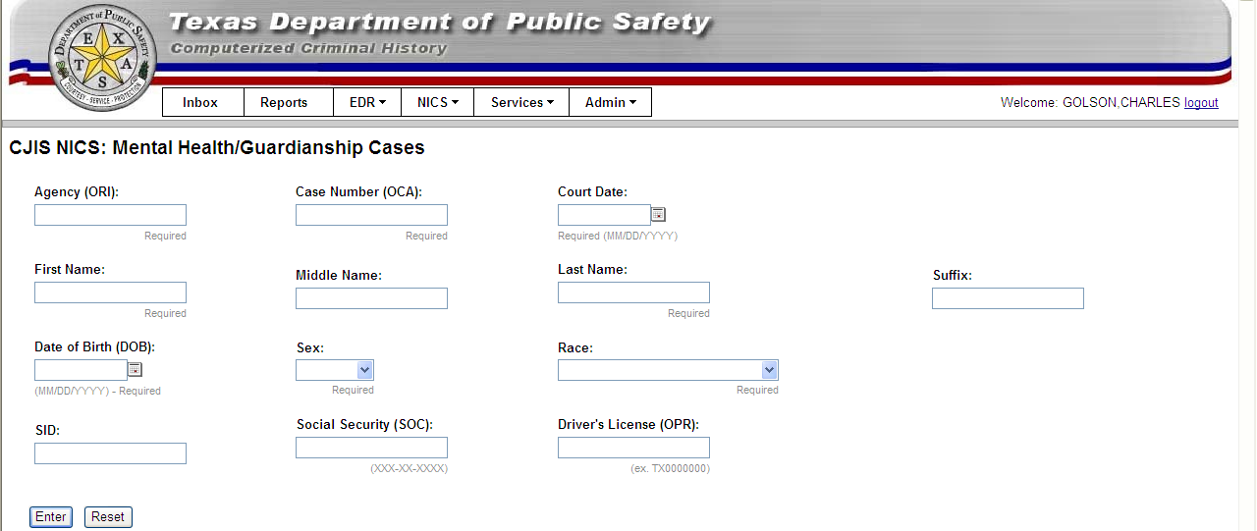

Enter your NICS transaction data, and click Enter.

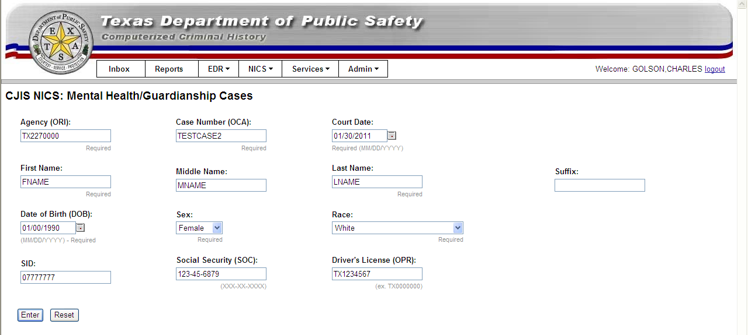

If the transaction is successful, a “NICS Record successfully created” message will display. You may enter your next NICS individual.

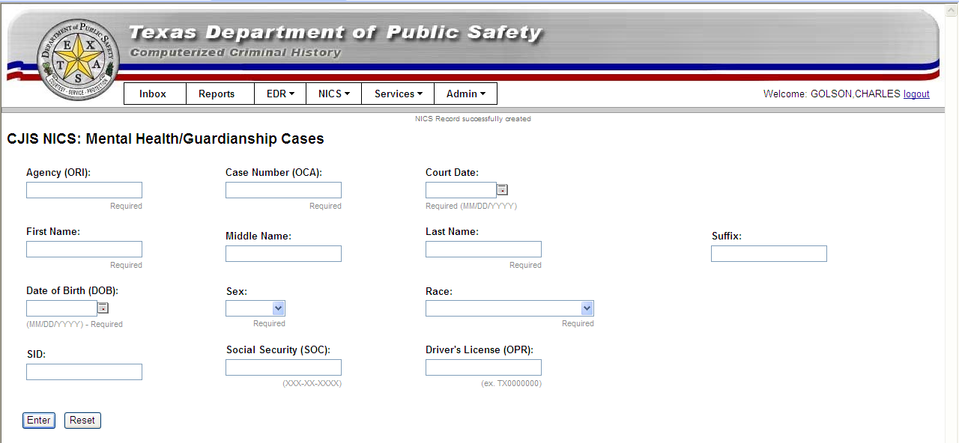

Any error messages will appear at the top of the entry form or as a pop up next to required fields.

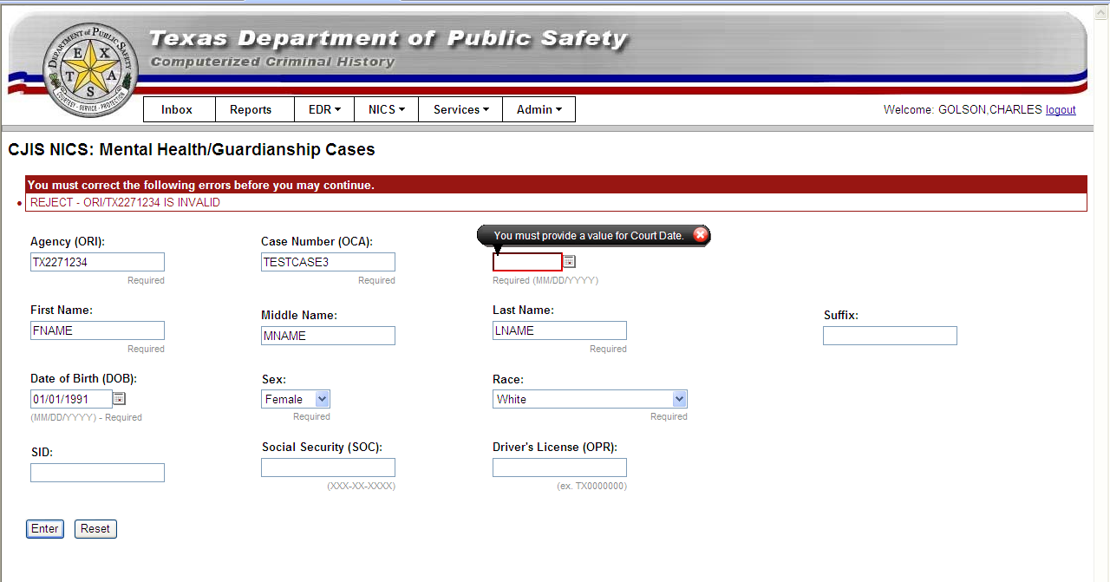

Correct the error and click Enter.

Online Entry of NICS Zero Activity Reports

NICS zero activity reports may be entered via the CJIS site by selecting NICS > Online Entry > Zero Report.

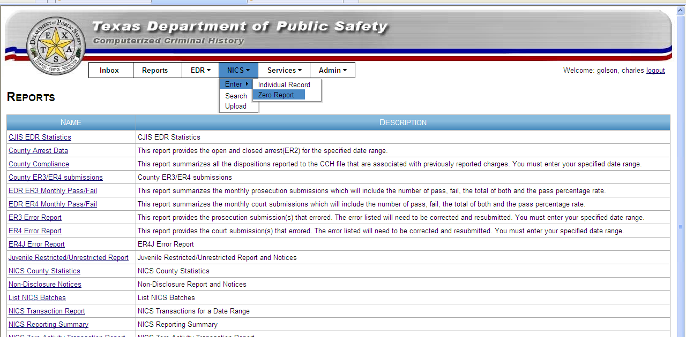

A blank entry form will be displayed with the counties for which you are authorized to enter NICS individuals.

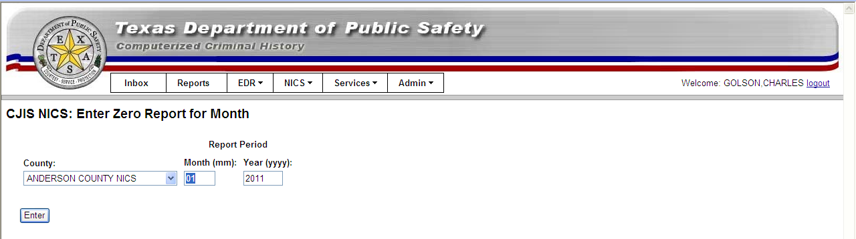

Select the County, Month, and Year for the Zero activity report and click Enter.

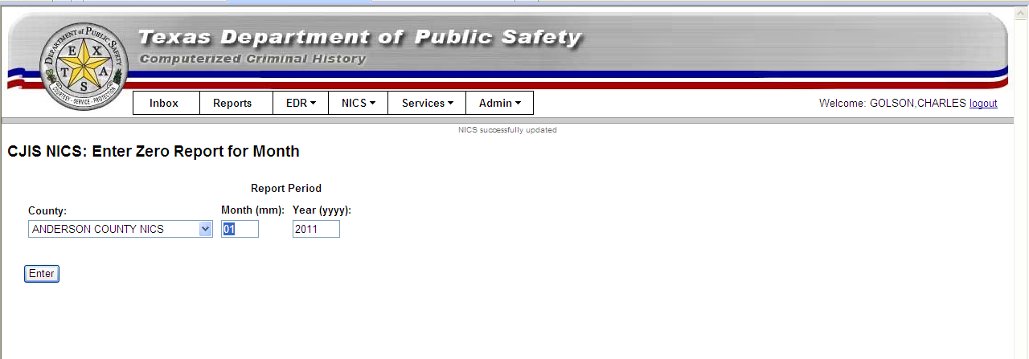

If the transaction is successful, a “NICS Successfully Updated” message will display at the top of the page.

Online Search and Cancel of NICS Transactions

To remove a NICS transaction from the database, select NICS > Search. To make modifications to a NICS record after it has been entered, you must first cancel the record and reenter it.

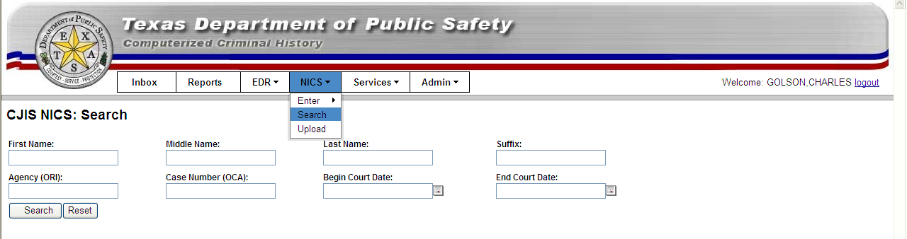

Enter your desired parameters and click Search.

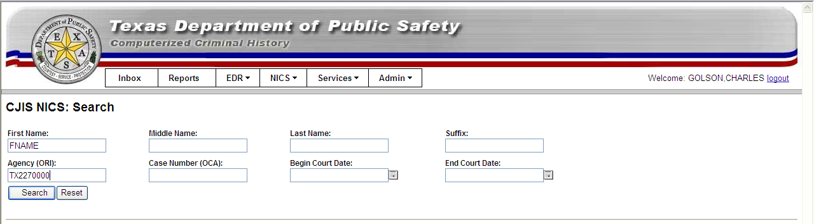
Any of your county’s entries that match your search criteria will be displayed:

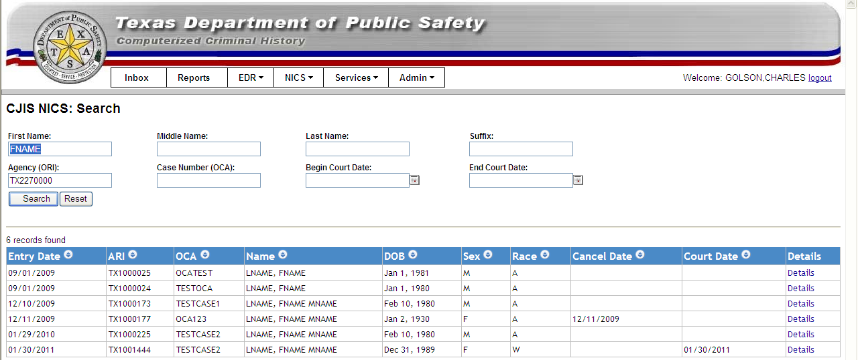

To view a record, select Details and its details will be displayed. To Cancel, click Cancel Record. Note that the Cancel Record button will not display if the record has already been cancelled.

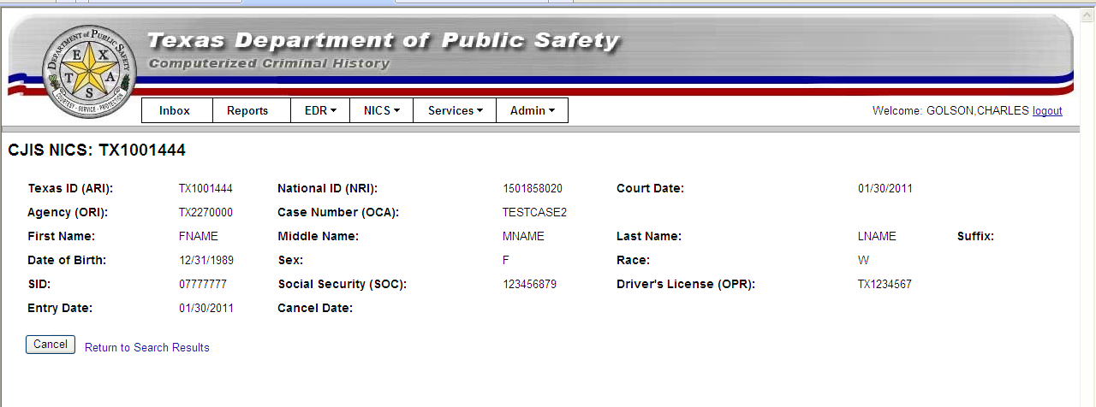

To confirm that you want to cancel the NICS entry, click OK.

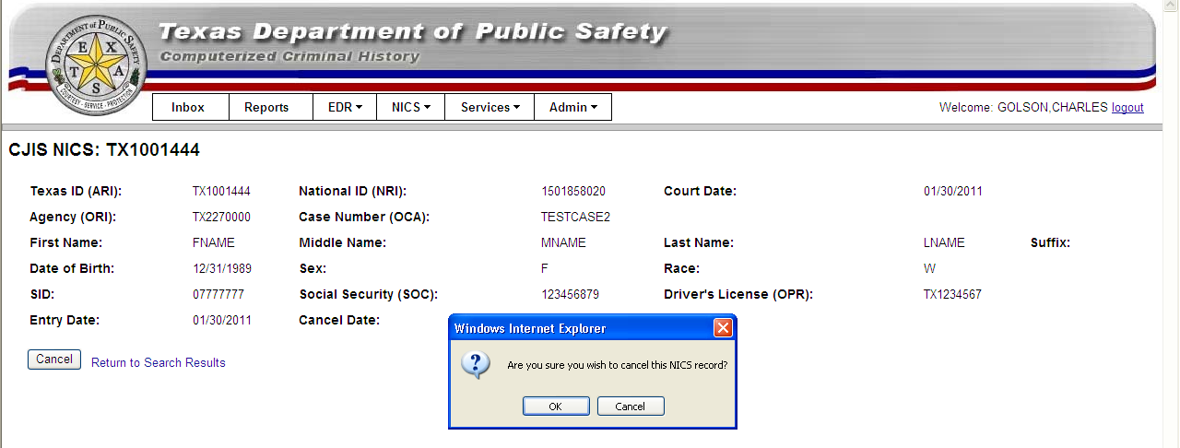

A confirmation message will be displayed and the Cancel Date will be filled in.

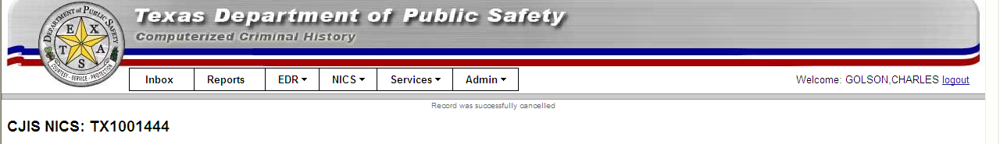
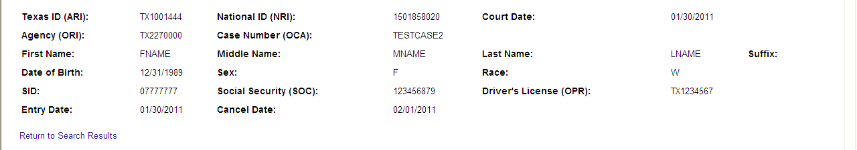

File Upload

To upload a text file of NICS transactions for processing, select NICS > Upload.

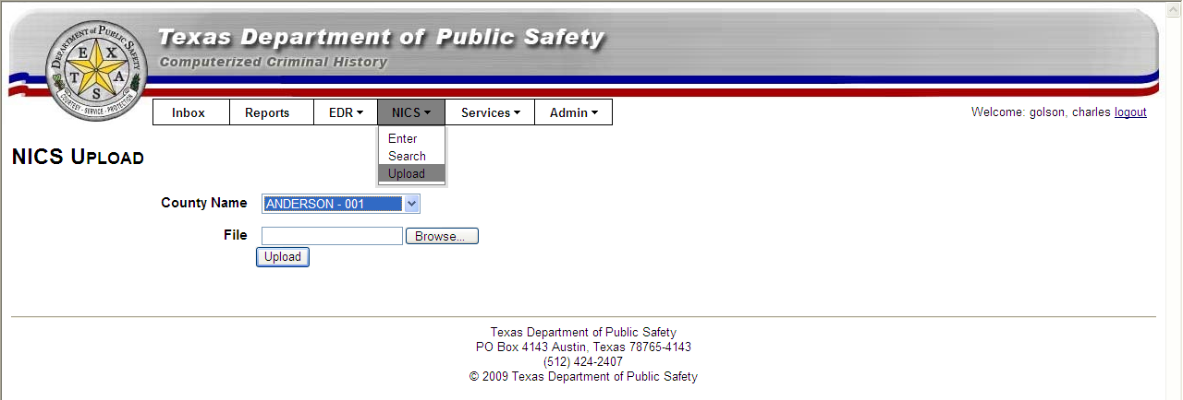

Select the county for your upload, then Browse, and Select your desired text file:

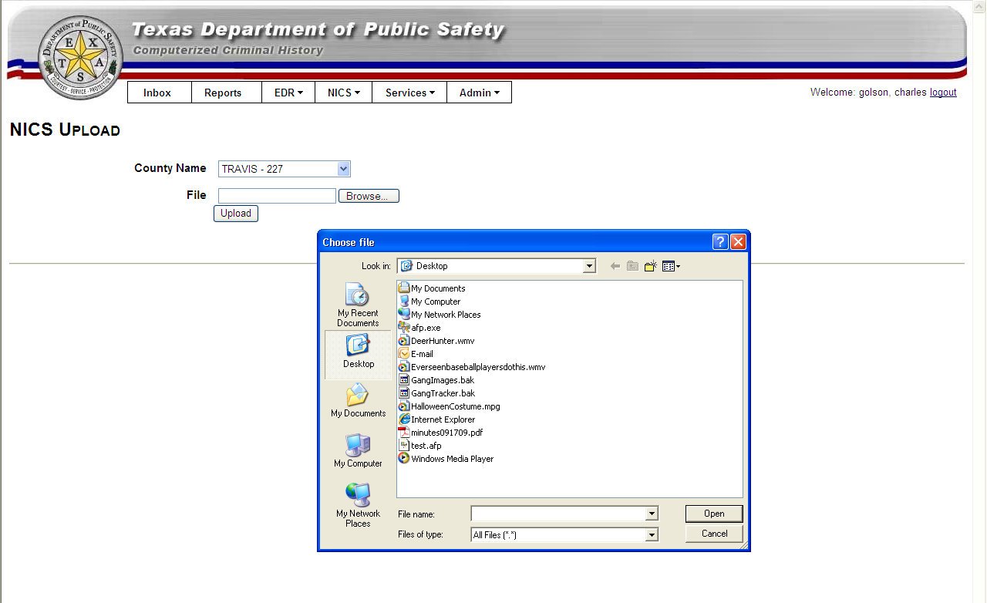

Click Upload and the the number of records uploaded will be displayed.

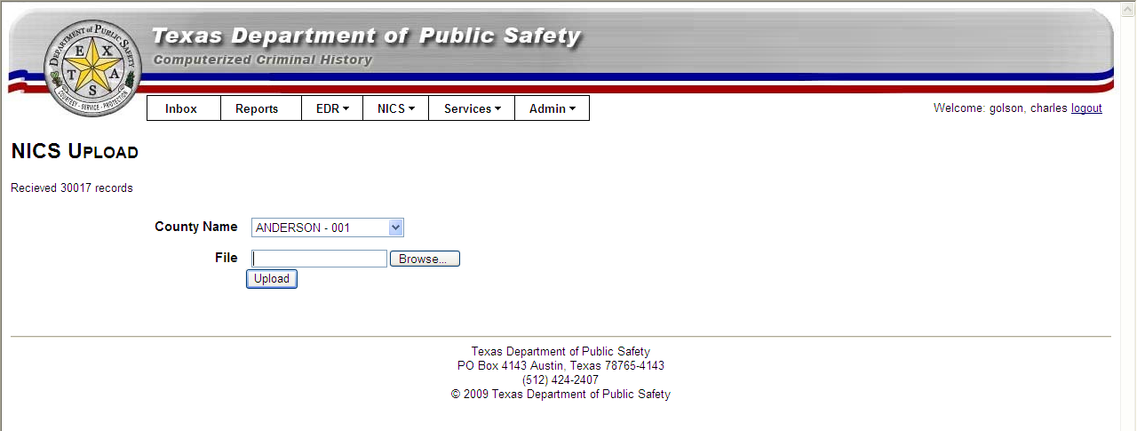

Reports

The Reports menu tab lists the reports which you are authorized to execute.

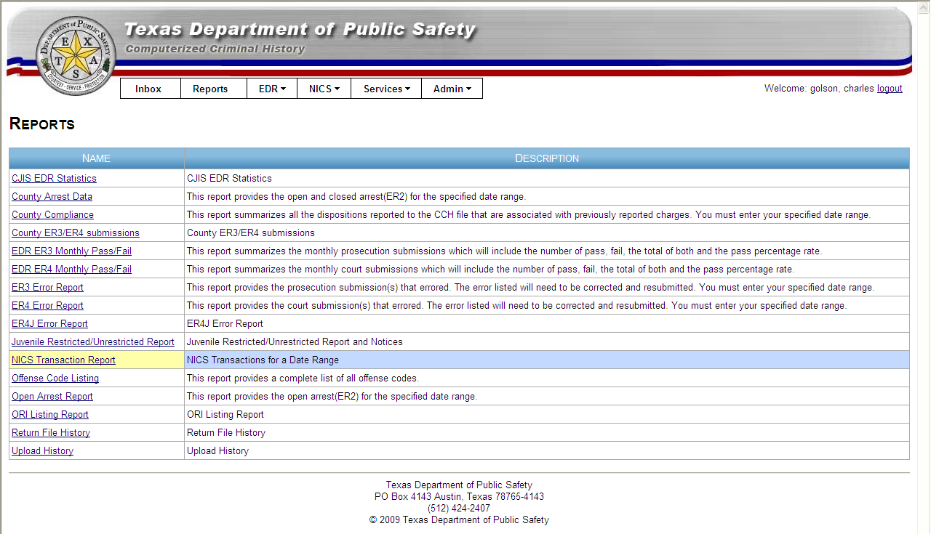

The following NICS Reports are available to assist with NICS compliance and reporting:

Report Name | Description
NICS County Compliance | NICS Compliance listed by month for the requested periods
NICS Transactions for a Date Range | List of NICS transactions entered during the date range and matching the additional search parameters
NICS Statewide Snapshot | List of current NICS statistics by county
NICS Zero Activity Transaction Report | List of NICS zero activity reports entered for a date range
List NICS Batches | List of NICS file uploads

Report Example – NICS Transaction Report

To execute a “NICS Transaction Report” for a county, select a county, a date range, and click Run Report.

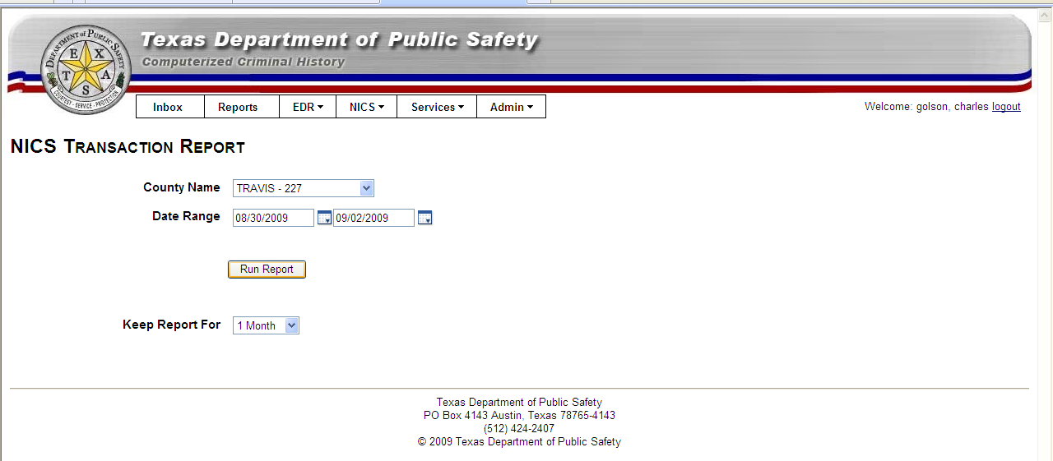

Note: The report will remain in your Inbox for one month. To adjust the retention period, change the Keep Report for prior to running the report.

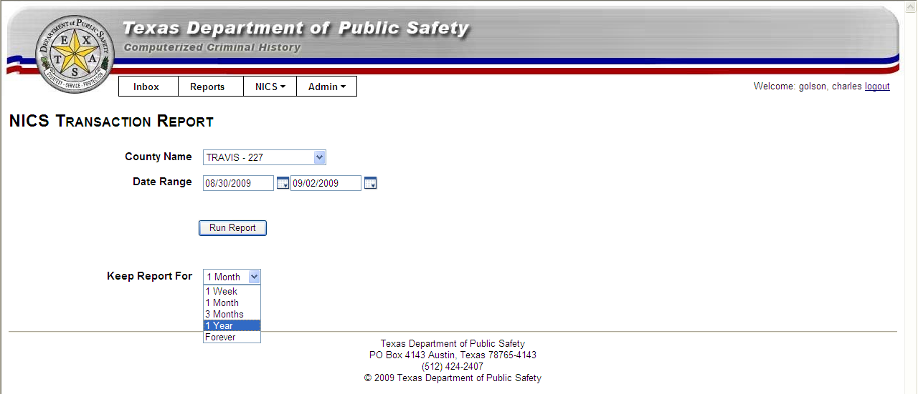
The sample NICS Transaction Report with the report parameters and number of records returned is shown below in the default format (HTML).

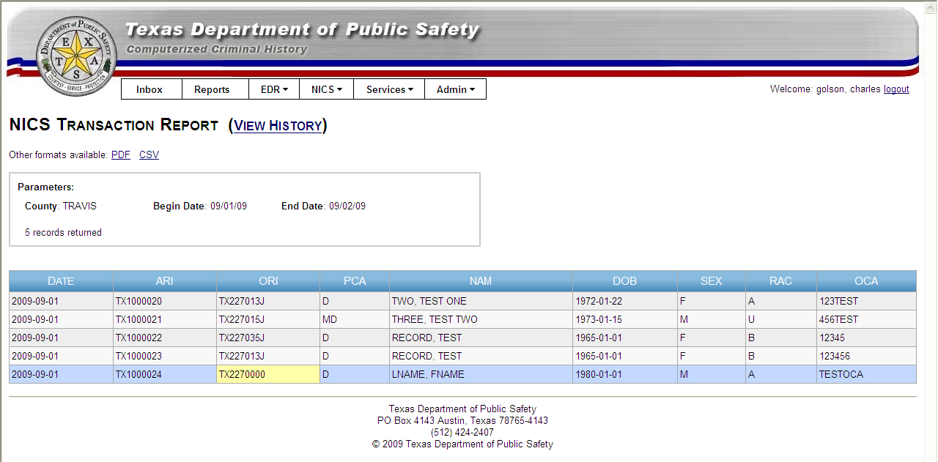

To display the report in another format, select the format and that report format (PDF in this example) will be displayed.

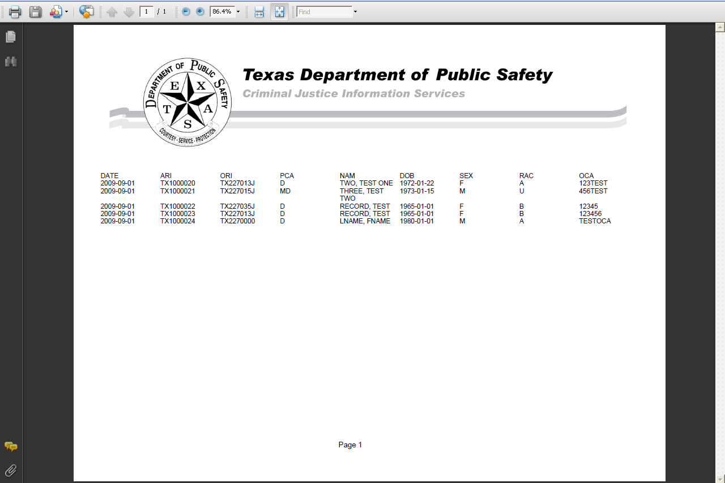

Reports for periods larger than 31 days must be run offline. If your report period is more than 31 days, the following page will be displayed:

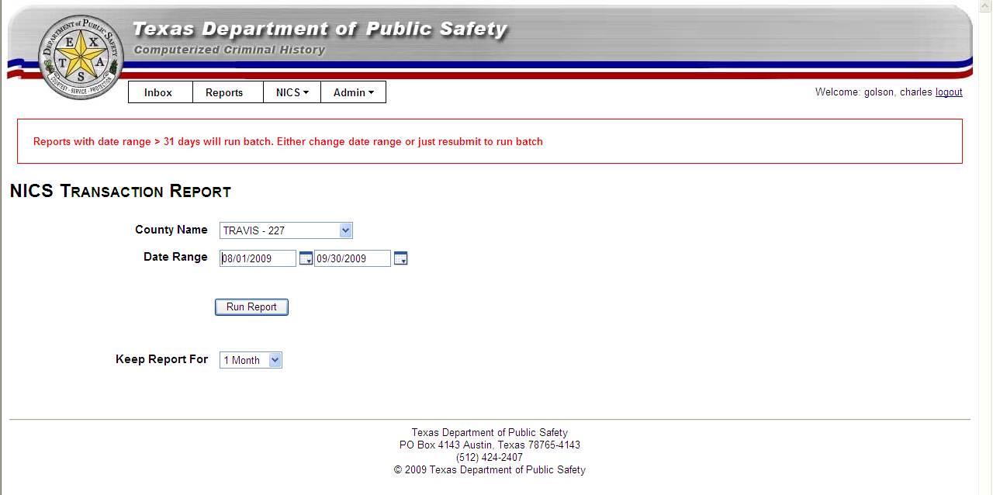

Click on Run Report again to submit a batch report request. You will receive an email confirmation when your report has completed and is available in your Inbox.

Report History

To see all instances of a particular report, click “View History”

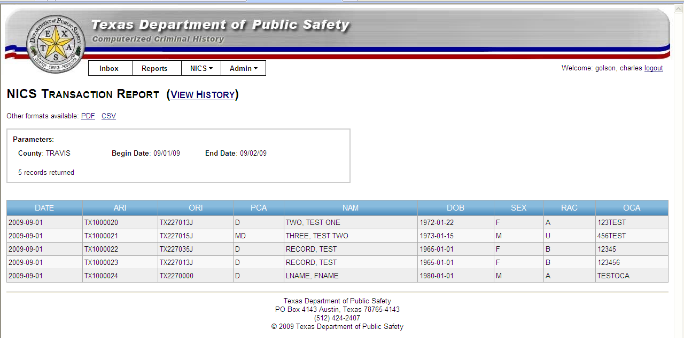

and all previous versions of that report type will be listed.

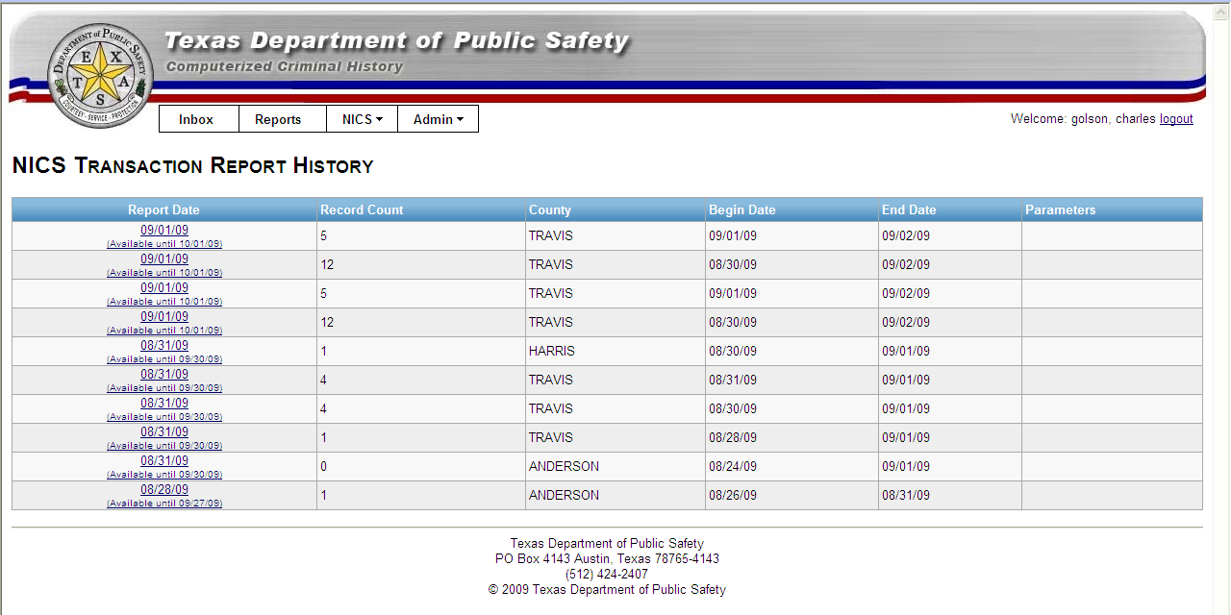

Transaction Formats

TRANSACTION HEADER

Each record sent to the DPS will be comprised of a 25-byte header and a single variable length record. The length of the record will depend on the type of transaction being submitted. The format of the transfer header is as follows:

TRANSFER RECORD FORMAT

| DATA TRANSFER HEADER | DATA AREA |
|----------------------------|-------------------------|
FIELD= |TRAN|CDC|FILLER |<------- RECORD -------->|
|----------------------------|-------------------------|
LGTH= | 4 4 17 |<- LENGTH OF RECORD----->|
|<-- TRANSACTION - LENGTH OF HEADER AND RECORD ------->|

Data  Element | Field  Location |  | Length | Definition
Data  Element | Begin | End | Length | Definition
TRANSACTION | 001 | 004 | 4 | 'CCHT' - TRANSACTION CODE FOR SENDING DATA TO THE DPS.
CDC | 005 | 008 | 4 | 'CDC' OF THE ORGANIZATION SUBMITTING THE DATA.
DATE | 009 | 016 | 8 | CURRENT DATE (YYYYMMDD)
FILLER | 017 | 025 | 9 | THE FINAL 9 CHARACTERS ARE NOT USED BY DPS AND CAN BE USED FOR COUNTY INFORMATION. HOWEVER THE FULL HEADER WILL BE INCLUDED UNCHANGED AS THE FIRST 25 CHARACTERS OF EACH RECORD IN THE RETURN FILE. THEREFORE, THE SUBMITTER MAY CHOOSE TO INCLUDE THE LAST 9 BYTES IN ANY FORMAT THEY DESIRE. THIS MAY BE IMPORTANT IF THE SOFTWARE BEING USED LOCALLY TO PROCESS THE SUBSEQUENT RETURN FILE IS DEPENDENT ON THIS DATA.

NICS ENTRY SEGMENT (MKE = ‘EDP’)

Note | Code | Field  Location |  | Length | Data  Type | Definition
Note | Code | Begin | End | Length | Data  Type | Definition
X | MKE | 001 | 004 | 4 | ANLJ | MESSAGE KEY 'EDP '. IDENTIFICATION RECORD.
 | ERR | 005 | 005 | 1 | A | ON RETURN TO AGENCY - BLANK = NO ERRORS - X = 500 BYTE ERROR FIELD APPENDED TO RECORD CONTAINING TEXT DESCRIPTION OF ANY ERRORS.
X | LGH | 006 | 009 | 4 |  | RECORD LENGTH (312)
X | DOE | 010 | 017 | 8 | N | DATE OF ENTRY (YYYYMMDD)
X | ORG | 018 | 021 | 4 | AN | CDC OF ORGANIZATION SUBMITTING DATA.  (I.E.:'DPS ', 'AFIS', ).
X | ORI | 22 | 30 | 9 | ANLJ | AGENCY IDENTIFIER
X | FNAM | 31 | 80 | 50 | A | NAME - FIRST
 | MNAM | 81 | 110 | 30 | A | NAME - MIDDLE
X | LNAM | 111 | 160 | 50 | A | NAME - LAST
 | SNAM | 161 | 164 | 4 | A | NAME - CADENCE
X | SEX | 165 | 165 | 1 | A | SEX. M = MALE,  F = FEMALE, U = UNKNOWN.
X | RAC | 166 | 166 | 1 | A | RACE. THE INIDVIDUAL'S NATIONALITY.
X | DOB | 167 | 174 | 8 | N | MONTH, DAY, AND COMPLETE YEAR OF INDIVIDUAL'S BIRTH.  MMDDYYYY
X | PCA | 175 | 176 | 2 | A | ‘D’ = ADJUDICATED MENTAL DEFECTIVE/COMMITTED TO A MENTAL INSTITUTION
X | OCA | 177 | 196 | 20 | ANLJ | ORIGINATING CASE NUMBER
 | ARI | 197 | 221 | 25 | ANLJ | AGENCY RECORD IDENTIFIER (ASSIGNED BY DPS AND INCLUDED IN RESPONSE)
 | SOC | 222 | 230 | 9 | N | SOCIAL SECURITY NUMBER
 | OLN | 231 | 255 | 25 | ANLJ | DRIVERS LICENSE NUMBER
 | DPS | 256 | 263 | 8 | NZFL | DPS (SID) NUMBER. DEPARTMENT OF PUBLIC SAFETY STATE IDENTIFICATION NUMBER
X | CDD | 264 | 271 | 8 | N | COURT DATE(YYYYMMDD)
 |  | 272 | 312 | 41 |  | CURRENTLY NOT USED

NICS CANCEL SEGMENT (MKE = ‘XDP’)

Note | Code | Field  Location |  | Length | Data  Type | Definition
Note | Code | Begin | End | Length | Data  Type | Definition
X | MKE | 001 | 004 | 4 | ANLJ | MESSAGE KEY 'XDP '. IDENTIFICATION RECORD.
 | ERR | 005 | 005 | 1 |  | ON RETURN TO AGENCY - BLANK = NO ERRORS - X = 500 BYTE ERROR FIELD APPENDED TO RECORD CONTAINING TEXT DESCRIPTION OF ANY ERRORS.
X | LGH | 006 | 009 | 4 |  | RECORD LENGTH (289)
X | DOE | 010 | 017 | 8 | N | DATE OF ENTRY (YYYYMMDD)
X | ORG | 018 | 021 | 4 | AN | CDC OF ORGANIZATION SUBMITTING DATA.  (I.E.:'DPS ', 'AFIS', ).
X | ORI | 22 | 30 | 9 | ANLJ | AGENCY IDENTIFIER
X | FNAM | 31 | 80 | 50 | A | NAME - FIRST
 | MNAM | 81 | 110 | 30 | A | NAME - MIDDLE
X | LNAM | 111 | 160 | 50 | A | NAME - LAST
 | SNAM | 161 | 164 | 4 | A | NAME - CADENCE
X | ARI | 165 | 189 | 25 | N | AGENCY RECORD IDENTIFER.FOR TEXAS NICS ENTRY
X | RDQ | 190 | 190 | 1 | A | RELIEF FROM DISABILITIES QUESTION – MUST BE Y OR N.  IS THIS DELETION DUE TO AN ATF-APPROVED STATE RELIEF FROM DISABILITIES PROGRAM?
 |  | 191 | 289 | 99 |  | DPS USE ONLY

ADMIN

Security profile

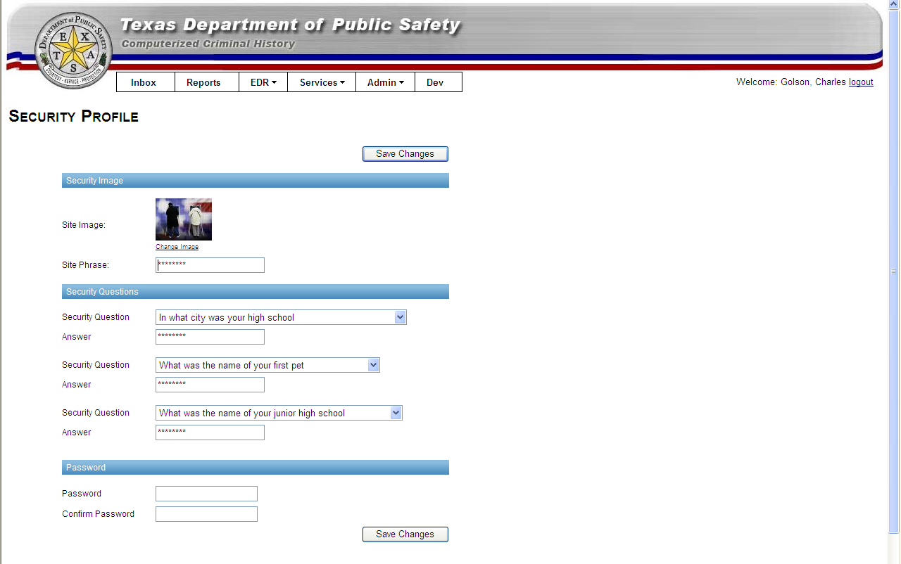

Security Image and Site Phrase

The security image and site phrase are used during the login process to allow you to verify that you are on the TxDPS CJIS web site. To change your image, click Change Image”. To change your phrase, enter your new phrase. Click Save Changes.

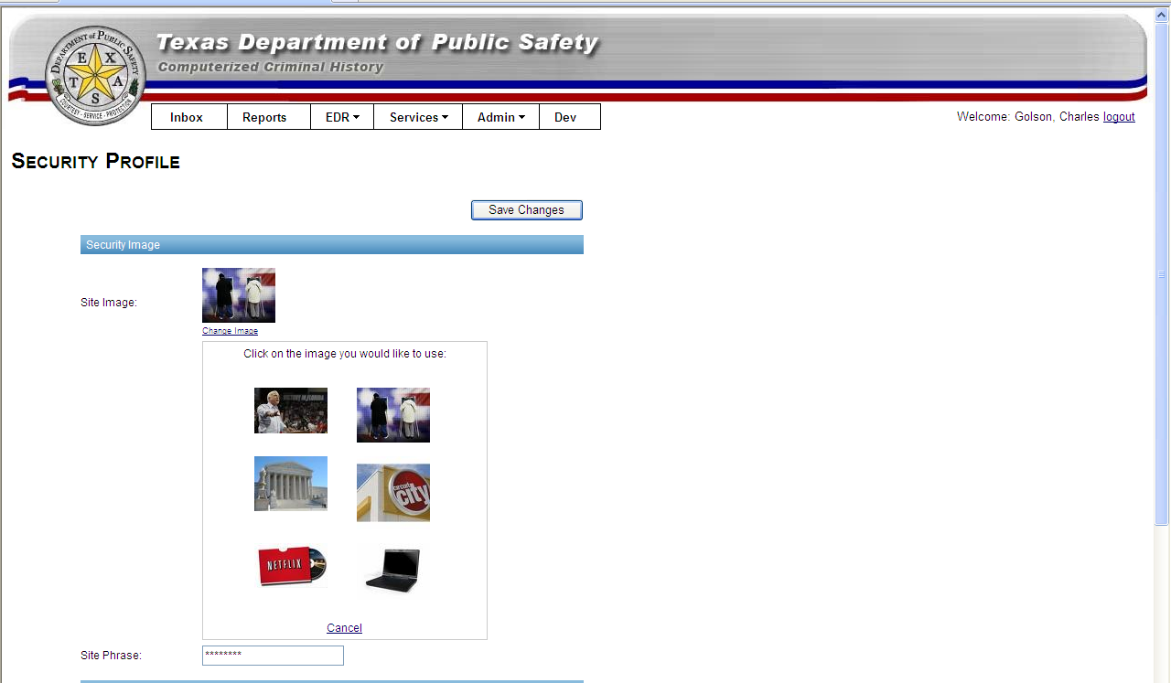

Security Questions

Security questions and answers are an additional method of identification. If your computer is not recognized by the CJIS site or if you have forgotten your password or it has expired, you will need to answer one of your security questions. To enter or change any of your question/answers, select the question, type an answer, and click Save Changes.

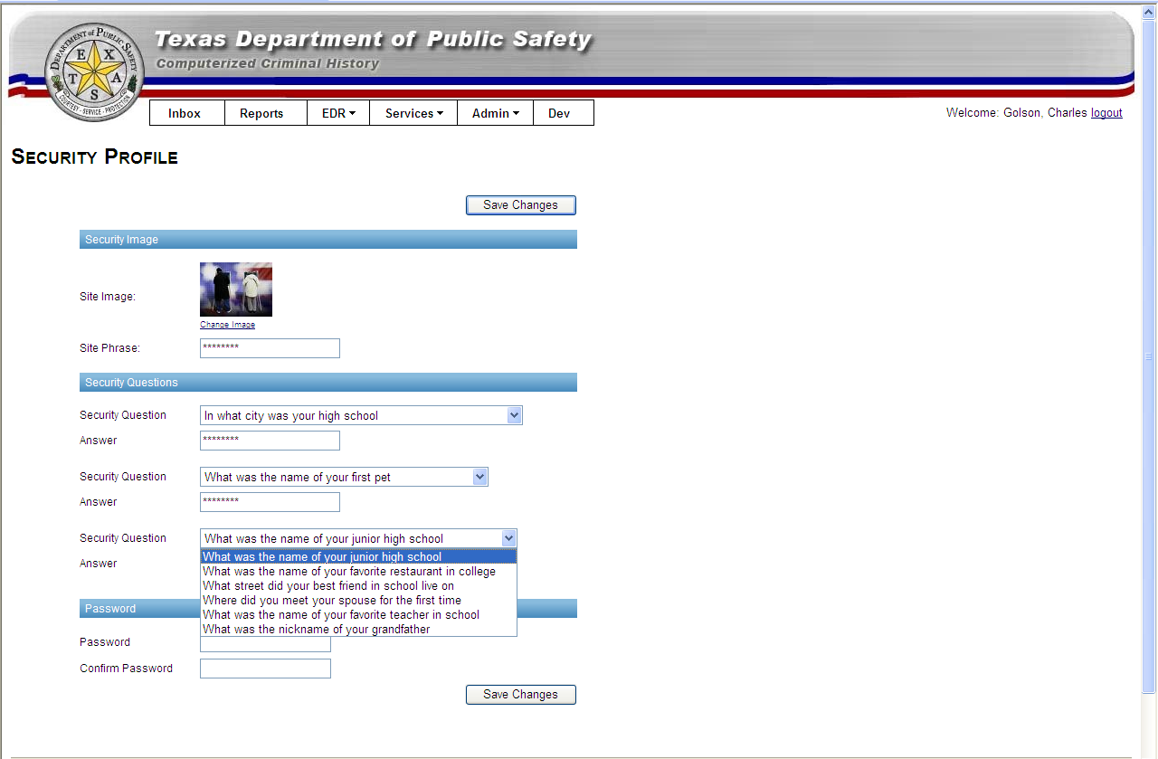

Passwords

Your Password can be changed from the Security Profile page by typing in the new password, confirming it, and clicking Save Changes.

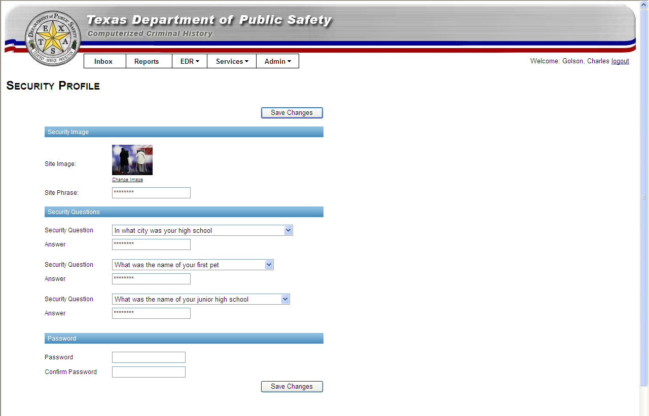

If you have fogotten your password, you may reset it by clicking the “Forgot your password?” link on the password entry page.

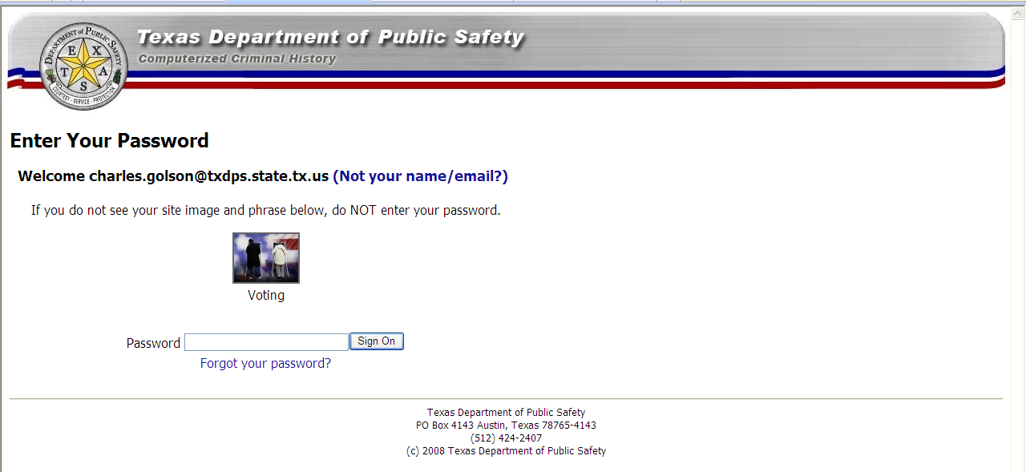

Provide the answer to your security question, enter your new password, retype it, and click Reset Password”.

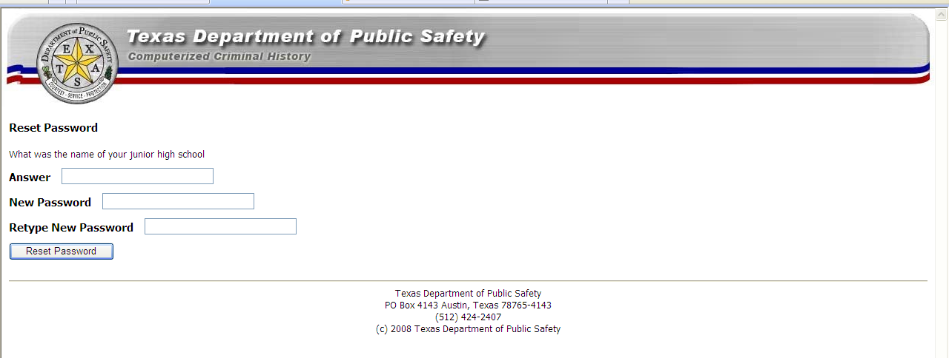

Authentication Code

The Authentication Code is used to register your computer as authorized to access the CJIS site. If your computer is not recognized by CJIS or if your authentication for your computer has expired, you will be prompted to request one.

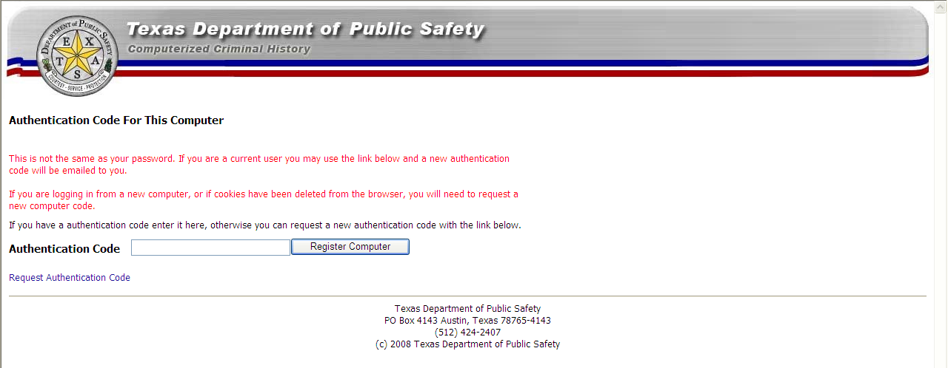

Upon request, one will be emailed your User ID.

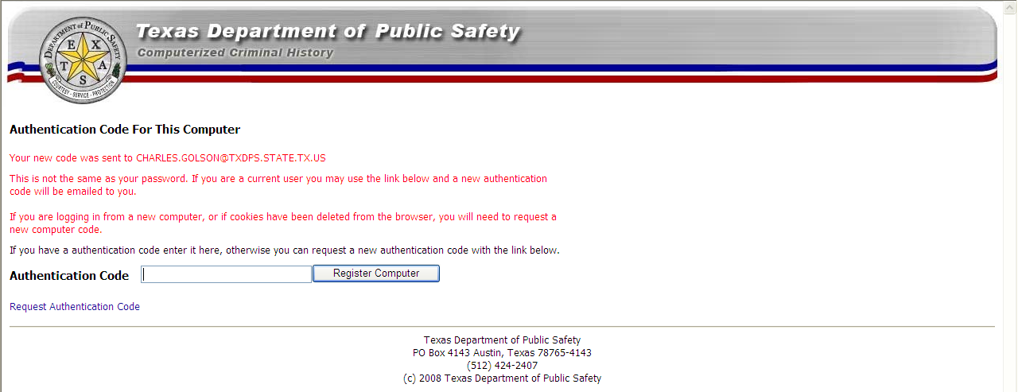

When you have received the email,

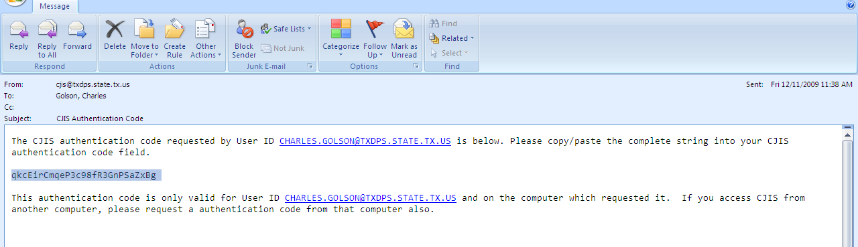

Please copy the code, paste it into the data field , and click REGISTER COMPUTER

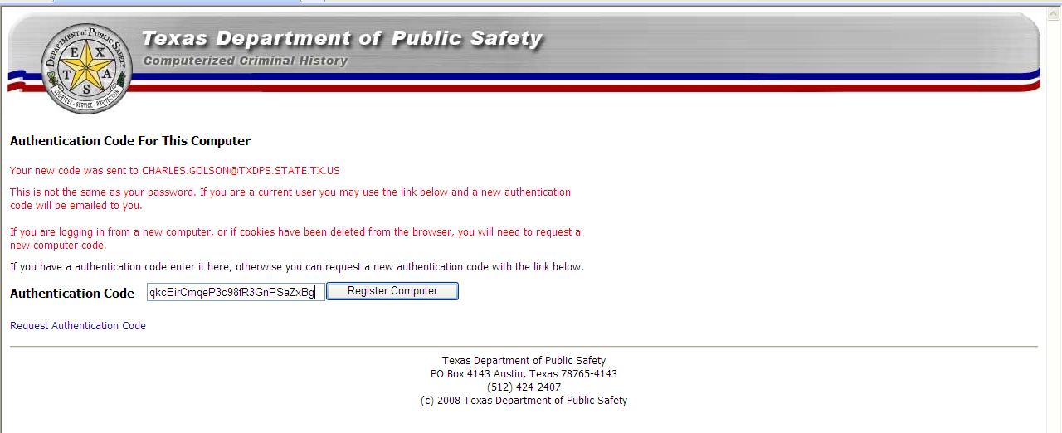

And proceed to the Enter Password page.


Authorized User Acknowledgement
Criminal Justice Information System (CJIS) Website

· Authorized users approved by the Department to use the criminal history record information (CHRI) have regular access to confidential criminal history information as a part of their job duties.

· All authorized users must clearly understand that any unauthorized retrieval, use or dissemination of this confidential information is a violation of state law and can lead to the filing of criminal charges against the authorized user, in addition to cancellation of access to the Department of Public Safety (DPS) database. The following is a copy of Texas Government Code Section 411.085, which describes the criminal penalties related to unauthorized retrieval, use, or dissemination of criminal history record information:
§ 411.085. Unauthorized Obtaining, Use, or Disclosure of Criminal History Record Information; Penalty
- A person commits an offense if the person knowingly or intentionally:
  - obtains criminal history record information in an unauthorized manner, uses the information for an unauthorized purpose, or discloses the information to a person who is not entitled to the information;
  - provides a person with a copy of the person's criminal history record information obtained from the department; or
  - violates a rule of the department adopted under this subchapter.
- An offense under Subsection (a) is a Class B misdemeanor, except as provided by Subsection (c).
- An offense under Subsection (a) is a felony of the second degree if the person:
  - obtains, uses, or discloses criminal history record information for remuneration or for the promise of remuneration; or
  - employs another person to obtain, use, or disclose criminal history record information for remuneration or for the promise of remuneration.
- The department shall provide each person who applies for access to criminal history record information maintained by the department with a copy of this section.
· Information regarding security requirements which must be followed by those who have access to CHRI is found in the Database Access and CJIS Security Policy.

I acknowledge that I understand above-mentioned law and policy applicable to my access to confidential criminal history record information and I understand their provisions. I further acknowledge that I am required to abide by the provisions of the above-mentioned law and policy.

Agency/Entity | Address | Phone Number
Printed User Name | Date of Birth | E-Mail Address
Signature |  | Date

“Access” is defined as physical access: The ability to receive, view, or discuss the Criminal History Record Information (CHRI) regardless of retrieval method from Texas Department of Public Safety.

Mail to:
DEPARTMENT OF PUBLIC SAFETY
CRIME RECORDS SERVICE
URSULA COOK
PO BOX 4143
AUSTIN TX 78765-4143

Document Revision History

Change 0. September 1, 2009
Version 1.0.0,first document to be released. Editor Ursula Cook

Change 1. March 10, 2010
Version 3.1.0,Added batch file updates and fixed file layouts. Editor Ursula Cook

Change 2. February 2, 2011
Version 3.1.0,Added Court Date field, Zero Activity entry, new NICS reports. Editor Ursula Cook

Change 3. March 30, 2011
Version 3.1.1,Corrected length of Filler column in fixed length Header. Editor Ursula Cook

Change 4. July 17, 2012
Version 3.1.2, Added mandatory RDQ field to cancel transaction (XDP). Editor Ursula Cook

